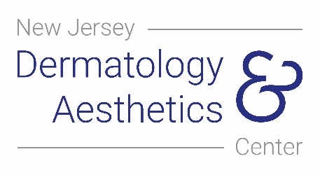
New Jersey Dermatology and Aesthetics Center

T (732) 702-1212

Consent to be Photographed

Consent to be Photographed

I consent for medical photographs to be taken of me by the staff or representatives of New Jersey Dermatology and Aesthetics Center. I understand that the images will be placed in my medical record and may be used for evaluation by employees of New Jersey Dermatology and Aesthetics Center. By consenting to these medical photographs, I understand that I will not receive payment from any party. Although these photographs will be used without identifying information such as my name, I understand that it is possible that someone may recognize me.

I also give permission for transfer of these photographs via a non-encrypted email exclusively for the purposes of third-party diagnostics, treatment and continuing medical care (e.g. communication with my primary care physician).

Refusal to consent to photographs will in no way affect the medical care I will receive.

If I wish to withdraw my consent in the future, I may do so with a written request.

_ Click or tap here to enter text.
____________________________
Patient or Legal Guardian

Date: Click or tap here to enter text.

479 County Rd 520 Suite A201 • Marlboro • New Jersey • 07746
T (732) 702-1212 • F (732) 526-4244 • www.njdermcenter.com

