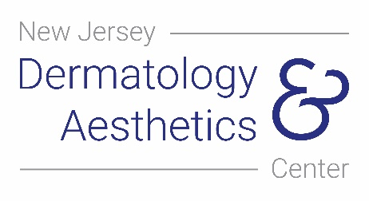
New Jersey Dermatology and Aesthetics Center

T (732) 702-1212

Insurance Signature on File

Insurance Signature on File

I certify that the information given by me in applying for Insurance and/or Medicare payment is true and correct. I authorize my doctor to act as my agent in helping me obtain payment of my Insurance and/or Medicare benefits, and I authorize payment of these benefits to Dr. Zain Husain on my behalf for any services and materials furnished. I authorize any holder of medical information about me to release to the Health Care Financing Administration and its agents any information needed to determine these benefits payable to related services. If I have other health insurance coverage (as indicated in Item 9 of the HCFA-1500 claim form or electronically submitted claim), my signature authorizes release of the above medical information to the insurer of agency shown, and authorizes my doctor to act as my agent, as above.

Click or tap here to enter text.
______________________________________
Patient or Legal Guardian

Date: Click or tap here to enter text.

479 County Rd 520 Suite A201 • Marlboro • New Jersey • 07746 Page 1 of 1 T (732) 702-1212 • F (732) 526-4244 • www.njdermcenter.com

